Okereke Chidinma Blessing
18/MHS04/004
PHS 204- Endocrine Physiology
Assignment Submitted to Dr. Akintayo Christopher
Department of Human Nutrition and Dietetics
College of Medicine and Health Sciences

Discuss Lactation and Gestation Period In A Normal Female

PHYSIOLOGY OF LACTATION
Lactation is the secretion of milk from specialized glands (mammary glands) to provide nourishment to offspring.

OVERVIEW OF LACTATION
Lactation describes the secretion of milk from the mammary glands and the period of time that a mother lactates to feed her young. The process occurs in all female mammals, although it predates the origin of mammals. In humans the process of feeding milk is called breastfeeding or nursing. The chief function of lactation is to provide nutrition and immune protection to the young after birth. In almost all mammals, lactation induces a period of infertility, which serves to provide the optimal birth spacing for survival of the offspring. In most species, milk comes out of the mother’s nipples. Galactopoietics is the maintenance of milk production. This stage requires prolactin and oxytocin.

PREPARATION FOR LACTATION
By the fifth or sixth month of pregnancy, the breasts are ready to produce milk. During the latter part of pregnancy, the woman’s breasts enter into the lactogenesis I stage. This is when the breasts make colostrum, a thick, sometimes yellowish fluid. At this stage, high levels of progesterone inhibit most milk production. It is not a medical concern if a pregnant woman leaks any colostrums before her baby’s birth, nor is it an indication of future milk production. At birth, prolactin levels remain high, while the delivery of the placenta results in a sudden drop in progesterone, estrogen, and human placental lactogen levels. This abrupt withdrawal of progesterone in the presence of high prolactin levels stimulates the copious milk production of the lactogenesis II stage. When the breast is stimulated, prolactin levels in the blood rise and peak in about 45 minutes, then return to the pre-breastfeeding state about three hours later. The release of prolactin triggers the cells in the alveoli to make milk.

COLOSTRUM
Colostrum is the first milk a breastfed baby receives. It contains higher amounts of white blood cells and antibodies than mature milk, and is especially high in immunoglobulin A (IgA), which coats the lining of the baby’s immature intestines, and helps to prevent pathogens from invading the baby’s system. Secretory IgA also helps prevent food allergies. Over the first two weeks after the birth, colostrums production slowly gives way to mature breast milk.

MILK EJECTION REFLEX
This is the mechanism by which milk is transported from the breast alveoli to the nipple. Suckling by the baby stimulates the par ventricular nuclei and supraoptic nucleus in the hypothalamus, which signals to the posterior pituitary gland to produce oxytocin. Oxytocin stimulates contraction of the myoepithelial cells surrounding the alveoli, which already hold milk. The increased pressure causes milk to flow through the duct system and be released through the nipple. This response can be conditioned e.g. to the cry of the baby. Milk ejection is initiated in the mother's breast by the act of suckling by the baby. The milk ejection reflex (also called let-down reflex) is not always consistent, especially at first. Once a woman is conditioned to nursing, let-down can be triggered by a variety of stimuli, including the sound of any baby. Even thinking about breastfeeding can stimulate this reflex, causing unwanted leakage, or both breasts may give out milk when an infant is feeding from one breast. However, this and other problems often settle after two weeks of feeding. Stress or anxiety can cause difficulties with breastfeeding. The release of the hormone oxytocin leads to the milk ejection or let-down reflex. Oxytocin stimulates the muscles surrounding the breast to squeeze out the milk. Breastfeeding mothers describe the sensation differently. Some feel a slight tingling, others feel immense amounts of pressure or slight pain/discomfort, and still others do not feel anything different.

MILK EJECTION REFLEX MECHANISM
This is the mechanism by which milk is transported from the breast alveoli to the nipple. Suckling by the baby innervates slowly-adapting and rapidly-adapting mechanoreceptors that are densely packed around the areola region. The electrical impulse follows the spinothalamic tract, which begins by innervations of fourth intercostals nerves. The electrical impulse then ascends the poster lateral tract for one or two vertebral levels and synapses with second-order neurons, called tract cells, in the posterior dorsal horn. The tract cells then decussate via the anterior white commissure to the anterolateral corner and ascend to the supraoptic nucleus and par ventricular nucleus in the hypothalamus, where they synapse with oxytocinergic third-order neurons. The
somas of these neurons are located in the hypothalamus, but their axon and axon terminals are located in the infundibulum and pars nervosa of the posterior pituitary, respectively. The oxytocin is produced in the neuron's soma in the supraoptic and par ventricular nuclei, and is then transported down the infundibulum via the hypothalamo-neurohypophyseal tract with the help of the carrier protein, neurophysin I, to the pars nervosa of the posterior pituitary, and then stored in Herring bodies, where they are stored until the synapse between second- and third-order neurons. Following the electrical impulse, oxytocin is released into the bloodstream. Through the bloodstream, oxytocin makes its way to myoepithelial cells, which lie between the extracellular matrix and luminal epithelial cells that also make up the alveoli in breast tissue. When oxytocin binds to the myoepithelial cells, the cells contract. The increased intra-aveolar pressure forces milk into the lactiferous sinuses, into the lactiferous ducts and then out the nipple.

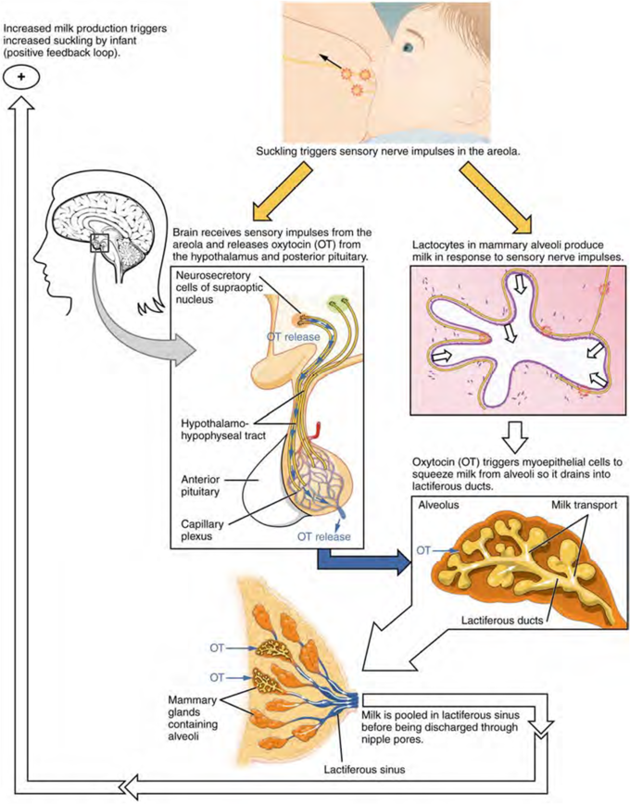

PHYSIOLOGY OF PREGNANCY
Pregnancy is divided into three trimesters, each lasting for approximately three months. The first trimester includes conception, which is when the sperm fertilizes the egg. The fertilized egg then travels down the fallopian tube and attaches to the inside of the uterus, where it begins to form the embryo and placenta. During the first trimester, the possibility of miscarriage (natural death of embryo or fetus) is at its highest. Around the middle of the second trimester, movement of the fetus may be felt. At 28 weeks, more than 90% of babies can survive outside of the uterus if provided with high-quality medical care. Prenatal care improves pregnancy outcomes. Prenatal care may include taking extra folic acid, avoiding drugs and alcohol, regular exercise, blood tests, and regular physical examinations. Complications of pregnancy may include disorders of high blood pressure, gestational diabetes, iron-deficiency anemia, and severe nausea and vomiting among others. In the ideal childbirth labor begins on its own when a woman is "at term". Babies born before 37 weeks are "preterm" and at higher risk of health problems such as cerebral palsy. Babies born between weeks 37 and 39 are considered "early term" while those born between weeks 39 and 41 are considered "full term". Babies born between weeks 41 and 42 weeks are considered "late term" while after 42 week they are considered "post term". Delivery before 39 weeks by labor induction or caesarean section is not recommended unless required for other medical reasons.

INITIATION
FERTILIZATION AND IMPLANTATION IN HUMANS
Through an interplay of hormones that includes follicle stimulating hormone that stimulates folliculogenesis and oogenesis creates a mature egg cell, the female gamete. Fertilization is the event where the egg cell fuses with the male gamete, spermatozoon. After the point of fertilization, the fused product of the female and male gamete is referred to as a zygote or fertilized egg. The fusion of female and male gametes usually occurs following the act of sexual intercourse. Pregnancy rates for sexual intercourse are highest during the menstrual cycle time from some 5 days before until 1 to 2 days after ovulation. Fertilization can also occur by assisted reproductive technology such as artificial insemination and in vitro fertilization. Fertilization (conception) is sometimes used as the initiation of pregnancy, with the derived age being termed fertilization age. Fertilization usually occurs about two weeks before the next expected menstrual period. This is time of implantation, when the future fetus attaches to the lining of the uterus. This is about a week to ten days after fertilization.
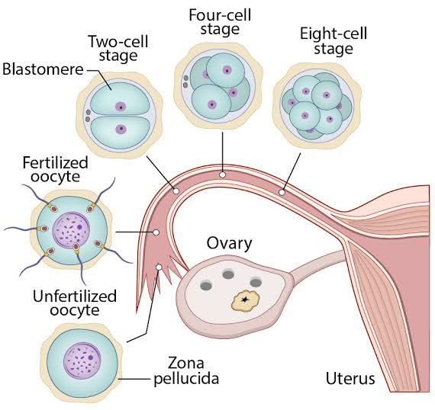

DEVELOPMENT OF EMBRYO AND FETUS
THE INITIAL STAGES OF HUMAN EMBRYOGENESIS
The sperm and the egg cell, which has been released from one of the female's two ovaries, unite in one of the two fallopian tubes. The fertilized egg, known as a zygote, then moves toward the uterus, a journey that can take up to a week to complete. Cell division begins approximately 24 to 36 hours after the female and male cells unite. Cell division continues at a rapid rate and the cells then develop into what is known as a blastocyst. The blastocyst arrives at the uterus and attaches to the uterine wall, a process known as implantation. The development of the mass of cells that will become the infant is called embryogenesis during the first approximately ten weeks of gestation. During this time, cells begin to differentiate into the various body systems. The basic outlines of the organ, body, and nervous systems are established. By the end of the embryonic stage, the beginnings of features such as fingers, eyes, mouth, and ears become visible. Also during this time, there is development of structures important to the support of the embryo, including the placenta and umbilical cord. The placenta connects the developing embryo to the uterine wall to allow nutrient uptake, waste elimination, and gas exchange via the mother's blood supply. The umbilical cord is the connecting cord from the embryo or fetus to the placenta.
After about ten weeks of gestational age, the embryo becomes known as a fetus. At the beginning it is about 30 mm (1.2 inches) in length, the heartbeat is seen via ultrasound, and the fetus makes involuntary motions. During continued fetal development, the early body systems, and structures that were established in the embryonic stage continue to develop. Sex organs begin to appear during the third month of gestation. The fetus continues to grow in both weight and length, although the majority of the physical growth occurs in the last weeks of pregnancy.
Electrical brain activity is first detected between the fifth and sixth week of gestation. It is considered primitive neural activity rather than the beginning of conscious thought. Synapses begin forming at 17 weeks, and begin to multiply quickly at week 28 until 3 to 4 months after birth. Although the fetus begins to move during the first trimester, it is not until the second trimester that movement, known as quickening, can be felt. This typically happens in the fourth month, more specifically in the 20th to 21st week, or by the 19th week.

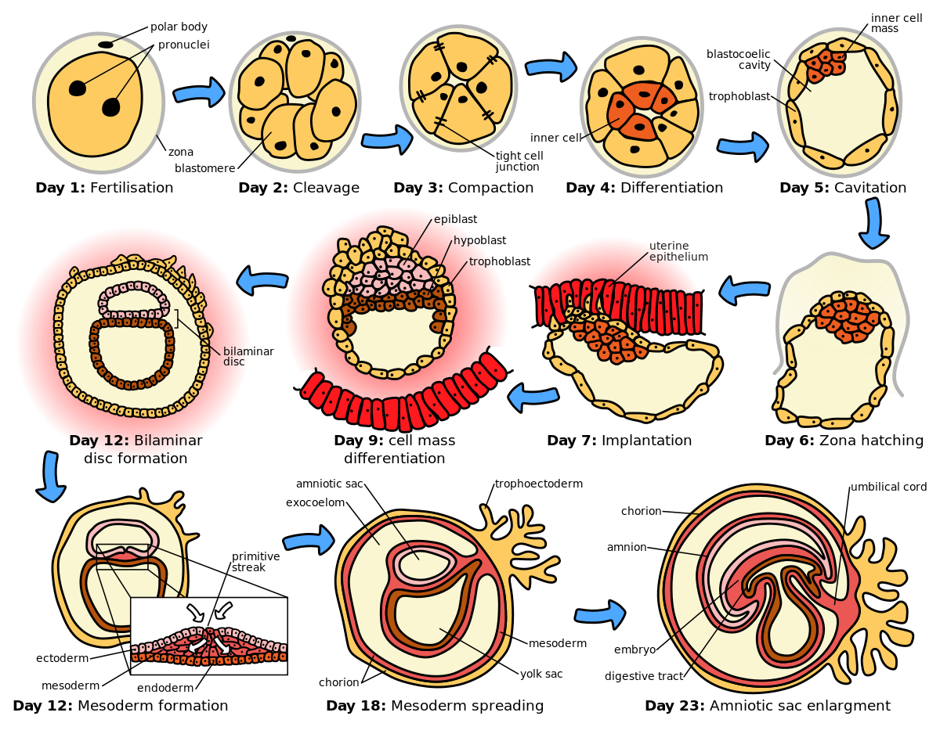

BIRTH AND PARTURITION
Birth, also called childbirth or parturition, process of bringing forth a child from the uterus,or womb. The process and series of changes that take place in a woman’s organs and tissues as a result of the developing fetus are discussed in the article pregnancy.
Initiation of Labour
Hormone like substances called prostaglandins, which are produced by the placenta in response to various biochemical signals, can induce inflammation and are present in increased levels during labour. Several factors that increase the production of prostaglandins include oxytocin, which stimulates the force and frequency of uterine contractions, and a fetal lung protein called surfactant protein A (SP-A).
THE STAGES OF LABOUR
FIRST STAGE: DILATATION
Early in labour, uterine contractions, or labour pains, occur at intervals of 20 to 30 minutes and last about 40 seconds. They are then accompanied by slight pain, which usually is felt in the small of the back. As labour progresses, those contractions become more intense and progressively increase in frequency until, at the end of the first stage, when dilatation is complete; they recur about every three minutes and are quite severe. With each contraction a two-fold effect is produced to facilitate the dilatation, or opening, of the cervix. Because the uterus is a muscular organ containing a fluid-filled sac called the amnion (or “bag of waters”) that more or less surrounds the child, contraction of the musculature of its walls should diminish its cavity and compress its contents. Because its contents are quite incompressible, however, they are forced in the direction of least resistance, which is in the direction of thymus, or upper opening of the neck of the uterus, and are driven, like a wedge, farther and farther into this opening. In addition to forcing the uterine contents in the direction of the cervix, shortening of the muscle fibres that are attached to the neck of the uterus tends to pull those tissues upward and away from the opening and thus adds to its enlargement. By this combined action each contraction of the uterus not only forces the amnion and fetus downward against the dilating neck of the uterus but also pulls the resisting walls of the latter upward over the advancing amnion, presenting part of the child.

SECOND STAGE: EXPULSION
About the time that the cervix becomes fully dilated, the amnion breaks, and the force of the involuntary uterine contractions may be augmented by voluntary bearing-down efforts of the mother. With each labour pain, she can take a deep breath and then contract her abdominal muscles. The increased intra-abdominal pressure thus produced may equal or exceed the force of the uterine contractions. These bearing-down efforts may double the effectiveness of the uterine contractions. As the child descends into and passes through the birth canal, the sensation of pain is often increased. This condition is especially true in the terminal phase of the stage of expulsion, when the child’s head distends and dilates the maternal tissues as it is being born.

THIRD STAGE: PLACENTAL STAGE
With the expulsion of the child, the cavity of the uterus is greatly diminished. As a consequence, the site of placental attachment becomes markedly reduced in size, with the result that the placenta (afterbirth) is separated in many places from the membrane lining the uterus. Within a few minutes subsequent uterine contractions complete the separation and force the placenta into the vagina, from which it is expelled by a bearing-down effort. The third stage of labour, accordingly, is of short duration, seldom lasting longer than 15 minutes.

